<HTML>

<HEAD>

<TITLE> Use of links </TITLE>

</HEAD>

<BODY>

<h2>code with link</h2>

<p> check this page with link</p>

<A HREF = Doc2.html> Click here. </A>

</BODY>

</HTML>



**Lab 7**

<HTML>

<HEAD>

<h2> Document 2. </h2>

</HEAD>

<BODY>

<p> Our second code with document 2 , please click here</p>

<A HREF = primer.html> main part </A>

</BODY>

</HTML>

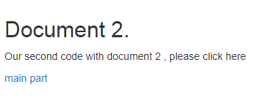

**Lab 8**

<HTML>

<HEAD>

<h2> History of Html </h2>

</HEAD>

<BODY>

<A HREF = #MySQL> Introduction </A>

<BR> <BR>

<A HREF = #MySQL's History> History </A>

<BR> <BR>

<A name = MySQL> Introduction </A>

<BR>

<P> <font color = black> HTML is standardized document markup language on the world wide web. Most web pages contain a description of the markup language HTML. The HTML language is interpreted by browsers; the resulting formatted text is displayed on the screen of a computer monitor or mobile device.

</font> </P>

<A name = MySQL's History> History </A>

<BR>

<P> <font color = red > HTML has had a life-span of roughly seven years. During that time, it has evolved from a simple language with a small number of tags to a complex system of mark-up, enabling authors to create all-singing-and-dancing Web pages complete with animated images, sound and all manner of gimmicks. This chapter tells you something about the Web's early days, HTML, and about the people, companies and organizations who contributed to HTML+, HTML 2, HTML 3.2 and finally, HTML 4.

</font> </P>

</BODY>

</HTML>

